Practical No.1C
Create a web application to find largest of two number using Simple SOAP service Server-Side Code:-
package server;import javax.jws.WebService;
import javax.jws.WebMethod;
import javax.jws.WebParam;
@WebService(serviceName = "LargeNumWS")
public class LargeNumWS {
@WebMethod(operationName = "findLargest")
public int findLargest(@WebParam(name = "num1") int num1,
@WebParam(name = "num2") int num2) {
return (num1 > num2) ? num1 : num2;
}
}
Server-Side Output:-
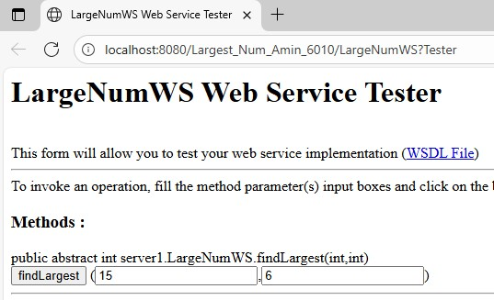
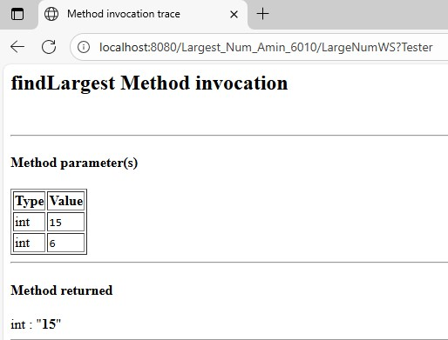

Client-Side Code:-
Input.jsp:-
<%--
Document : Input
Created on : Nov 24, 2025, 11:53:38 AM
Author : Administrator
--%>
<%@page contentType="text/html" pageEncoding="UTF-8"%>
<!DOCTYPE html>
<html>
<head>
<meta http-equiv="Content-Type" content="text/html; charset=UTF-8">
<title>JSP Page</title>
</head>
<body>
<h1>Amin Patel TYCS 6010</h1>
<h2>Enter Two Numbers</h2>

<form action="output.jsp" method="post">
<label>Enter Number 1:</label>
<input type="text" name="num1" required>
<br><br>

<label>Enter Number 2:</label>
<input type="text" name="num2" required><br><br>

<input type="submit" value="Find Largest">
</form>
</body>
</html>
Output.jsp:-
<%--
Document : output
Created on : Nov 24, 2025
Author : Administrator
--%>
<%@page import="server1.LargeNumWS"%>
<%@page import="server1.LargeNumWS_Service"%>
<%@page contentType="text/html" pageEncoding="UTF-8"%>
<!DOCTYPE html>
<html>
<head>
<meta charset="UTF-8">
<title>Largest Number - Output</title>
</head>
<body>
<h1>Amin Patel TYCS 6010</h1>
<h2>Result</h2>
<%
try {
// Receive values from input.jsp
int a = Integer.parseInt(request.getParameter("num1"));
int b = Integer.parseInt(request.getParameter("num2"));
// Call SOAP Web Service
LargeNumWS_Service service = new LargeNumWS_Service();
LargeNumWS port = service.getLargeNumWSPort();

int result = port.findLargest(a, b);
%>
<p><b>Number 1:</b> <%= a %></p>
<p><b>Number 2:</b> <%= b %></p>
<h3>Largest Number = <%= result %></h3>
<%
} catch (Exception ex) {
out.println("<h3>Error: " + ex.getMessage() + "</h3>");
}
%>
<br><br>
<a href="input.jsp">← Back to Input</a>
</body>
</html>
Client-Side Output:-
